1. Screen configuration standardizations
   1. Display

Number of colors supported: 16,777,216 colors

Resolution:1366×768

* 1. Screen

Location of standard buttons: At the bottom (vertically) and in the middle(horizontally) of the frame

Location of the messages: Starting from the top vertically and in the middle horizontally of the frame down to the bottom.

Display of the screen title: The title is located at the top of the frame in the middle.

Consistency in expression of alphanumeric numbers: comma for separator of thousand while strings only consist of characters, digits, commas, dots, spaces, underscores, and hyphen symbol.

* 1. Control

Size of the text: medium size (mostly 24px).

Font: Segoe UI.

Color: #000000

Input check process: Should check if it is empty or not. Next, check if the input is in the correct format or not.

Sequence of moving the focus: There will be no stack frames. Each screen will be separated. However, the manual is considered a popup message, as the main screen cannot be operated while the manual screen is shown. Since the use case is based on ”Place Order” use case, the main screen of this use case is the same as the input delivery information of the “Place Order” use case. The use case begin when choosing an order options, there will be two popup messages to show the user:

1. Which product is supported, and the total fee of the rush order

2.(in case no product is supported) No supportable product

The Place Order use case will only be success if the user click(or tap) on the “Agree” Button of the “Supported products & Total fee” pop-up.

Sequences of the screens:

1. Input Delivery Information (first screen)

2.Supported products & Total fee

3.No supported Product

* 1. Direct input from the keyboard

There will be no shortcuts. There are back buttons to move back to the previous screen. Also, there is the close button “X” located at the title bar to the right to close the screen.

* 1. Error

A message will be given to notify the users what is the problem

1. Mockup design

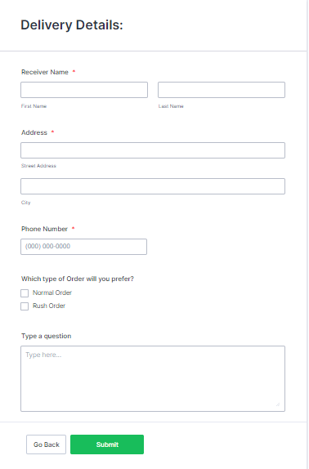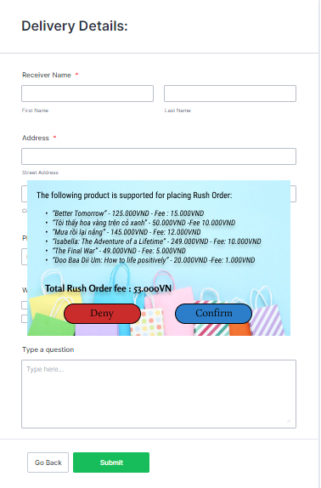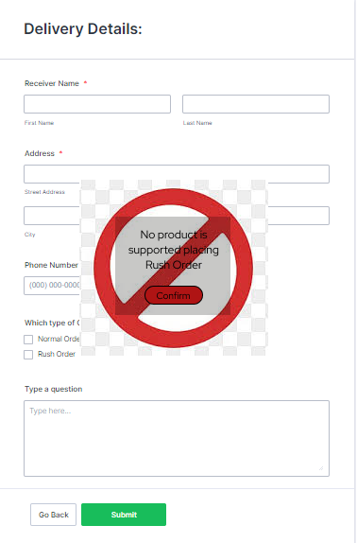

1. screen transition diagrams

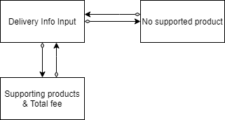

1. detailed screen specifications

|  |  |  |  |  |  |
| --- | --- | --- | --- | --- | --- |
| AIMS Software | | Date of creation | Approved by | Reviewed by | Person in charge |
| Screen specification | Suppoted product & Total fee | 25/10/2021 |  |  | Lê Huy Hoàng |
|  | | Control | Operation | Function | |
| Area for displaying the supported products | Initial | Display the supported products | |
| Area for displaying the total fee | Initial | Display the total fee | |
| Deny button | Click | Cancel the place rush order | |
| Confirm button | Click | Approve the place rush order | |

|  |  |  |  |  |  |
| --- | --- | --- | --- | --- | --- |
| AIMS Software | | Date of creation | Approved by | Reviewed by | Person in charge |
| Screen specification | No supported product | 25/10/2021 |  |  | Lê Huy Hoàng |
|  | | Control | Operation | Function | |
| Confirm button | Click | Approve the place rush order | |
|
|
|